Progress Report
Dong Wuzheng A0352274E
Yang Guanxi A0356000X
Gao Hongye A0351080R

1 Introduction
This project implements a distributed attention kernel for long sequences and measures its correctness and runtime on CPU and NVIDIA GPUs. Standard attention computes every query against every key, so for fixed feature dimensions, the arithmetic complexity of dense attention grows quadratically with sequence length $N$.. Ring Attention distributes query and key/value blocks across GPUs: each GPU keeps its query block, while key/value blocks circulate between ranks. This lets the GPUs share the attention work without gathering the complete key/value sequence on every device.

2 Methodology

2.1 Attention Formulation and Notation
For queries$Q$, keys$K$, values$V$, and key dimension$d_{k}$, the reference operation is:
$$\begin{aligned}S&=\frac{QK^{⊤}}{\sqrt{d_{k}}} \\ O&=\text{softmax}\left(S+M\right)V\end{aligned}$$
In our implementation and empirical evaluations,$d$ and $d_{v}$ denote the feature dimensions of the query/key vectors and value vectors, respectively. Accordingly, the associated matrices satisfy $Q,K∈R^{N×d}$ and $V,O∈R^{N×d_{v}}$.
Here M is zero for allowed positions and −∞ for masked positions. In causal attention, a query at position i cannot use a key at a later position j> i.

2.2 Ring Attention and Blocking
Ring Attention partitions the query rows across GPU ranks. Each rank keeps its assigned query block and processes key/value blocks that circulate between ranks. The query block is divided into tiles of $B_{q}$ rows, while the key and value blocks are divided into tiles of$B_{k}$ rows. For each query tile, a rank computes attention against the key/value tiles as they arrive around the ring.
Blocking is applied to two loops. The query-row loop processes $b_{q}$ rows together; the key/value loop processes $b_{k}$ positions per tile as the blocks circulate between ranks. Each arriving key/value tile updates the running softmax state for the retained query block, avoiding construction of the full N×N score matrix.
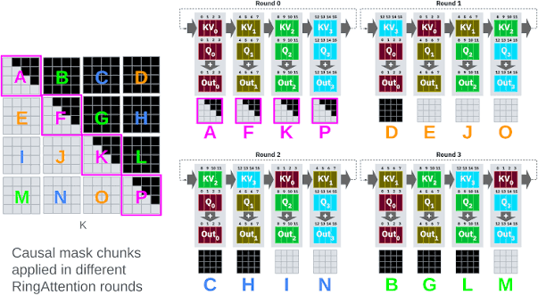
Figure 1. Each rank retains its query block and processes key/value tiles circulated around the GPU ring.
For each query row, the implementation maintains a running maximum $m$, a softmax denominator$l$, and a weighted value sum$u$. For a new score tile $s$, it updates these quantities as follows:
$$m'=\max\left(m,\max_{j}{s_{j}}\right)$$
$$l'=e^{m-m'}l+\sum_{j}{e^{s_{j}-m'}}, \\ u'=e^{m-m'}u+\sum_{j}{e^{s_{j}-m'}}v_{j}.$$
After all key/value tiles have been processed, the output row is $u/l$. This online update avoids storing the full$N×N$ attention-score matrix; intermediate scores are processed tile by tile. With fixed feature dimensions, the attention computation still grows quadratically with $N$.

3 Experiment
We evaluated five execution configurations: serial CPU, OpenMP CPU, local single-GPU CUDA on an NVIDIA RTX 4090, single-GPU CUDA on a Vanda A40, and two-node MPI+CUDA on two Vanda A40 GPUs. Performance measurements used$d=d_{v}=64$ and five repetitions unless otherwise stated. Small correctness tests used $N=257$, $d=31$, and $d_{v}=19$.

3.1 Serial CPU (FP64)
The serial CPU implementation used FP64 arithmetic and served as the CPU reference. Performance was measured at sequence lengths$N=512$, 1024, 2048, and 4096. Table 1 reports the measured runtimes.
Table 1. Serial CPU FP64 runtimes with$d=d_{v}=64$.
Sequence length $N$ | Median runtime
512 | 17.515 ms
1024 | 70.418 ms
2048 | 263.479 ms
4096 | 913.966 ms

3.2 OpenMP CPU (FP64)
The OpenMP CPU implementation used FP64 arithmetic. At $N=4096$, with $d=d_{v}=64$, we measured runtimes using 1, 2, 4, and 8 threads. Table 2 reports the measured runtimes.
Table 2. OpenMP CPU runtimes at $N=4096$,$d=d_{v}=64$.
CPU threads | Median runtime
1 | 914.491 ms
2 | 450.942 ms
4 | 236.177 ms
8 | 142.854 ms

3.3 Loval single GPU CUDA (RTX4090)
The local CUDA implementation was run on a single NVIDIA GeForce RTX 4090. The tests covered full and causal attention at $N=257$, followed by full-attention runs at $N=1024$ and $N=4096$. All four tests were checked against the FP64 CPU reference and passed validation.
Table 3. Local RTX 4090 CUDA validation and runtime results.
Test | Runtime | Validation
$N=257$, full attention | 0.609 ms | PASS
$N=257$, causal attention | 0.589 ms | PASS
$N=1024$, full attention, 5 repetitions | 0.718 ms | PASS
$N=4096$, full attention, 5 repetitions | 8.044 ms | PASS
The terminal captures which show the local GPU and the recorded CUDA validation and benchmark outputs are attached in Appendix 1.

3.4 Vanda Single GPU CUDA (A40, FP32)
The single-GPU CUDA implementation was run on one Vanda A40 GPU using FP32 arithmetic. The Vanda environment used CUDA Toolkit 12.4. Performance was measured at $N=512$, 1024, 2048, and 4096, with $d=d_{v}=64$.
Table 4. Vanda single-GPU A40 FP32 runtimes with $d=d_{v}=64$.
Sequence length $N$ | Median runtime
512 | 0.248 ms
1024 | 0.648 ms
2048 | 2.345 ms
4096 | 8.845 ms

3.5 Vanda Two-Node MPI+CUDA (2 × A40, FP32)
The distributed CUDA implementation was run on two Vanda nodes, with one A40 GPU per node. It used FP32 arithmetic, CUDA Toolkit 12.4, Open MPI 4.1.8, and host-staged MPI communication.
The first two-node attempt, Job 1475534, received two A40 nodes but stopped before GPU computation because Open MPI placed both ranks on the first node. We changed the launch mapping to place one rank on each node. The subsequent smoke test and full benchmark confirmed distinct rank hosts and completed successfully.
The reported two-node MPI+CUDA runtime was 5.115 ms at $N=4096$ and 18.908 ms at $N=8192$. Full and causal correctness tests at $N=257$, $d=31$, and $d_{v}=19$ both passed.
Table 5. Two-node Vanda correctness results against the FP64 CPU reference.
Attention mode | Input | Maximum absolute error | Relative L2 error | Result
Full | $$N=257, d=31, d_{v}=19$$ | 2.5164e-08 | 1.2781e-07 | PASS
Causal | $$N=257, d=31, d_{v}=19$$ | 7.4686e-08 | 8.9793e-08 | PASS
For each output element $y_{i}$ and FP64 reference value $y_{ref}$,i, maximum absolute error is $max_{i}\left|y_{i}-y_{ref},i\right|$, and relative L2 error is$\frac{‖y-y_{\text{ref}}‖_{2}}{‖y_{\text{ref}}‖_{2}}$. Full and causal attention are checked separately against the reference.

4 Result

4.1 Performance Comparison
Table 6 compares attention runtime across sequence lengths for four configurations: serial CPU FP64, serial CPU FP32, Vanda A40 FP32, and Vanda A40 FP64.
Table 6. Attention runtime across sequence lengths for serial CPU and single-GPU Vanda A40 configurations.
$$N$$ | Serial CPU FP64 | Vanda A40, one-GPU FP32 | Serial CPU FP32 | Vanda A40, single-GPU FP64
512 | 17.515 ms | 0.248 ms | 14.486 ms | 0.568 ms
1024 | 70.418 ms | 0.648 ms | 56.536 ms | 1.869 ms
2048 | 263.479 ms | 2.345 ms | 155.295 ms | 7.187 ms
4096 | 913.966 ms | 8.845 ms | 678.629 ms | 28.348 ms
8192 | 4146.970 ms | 33.379 ms | 3041.366 ms | 113.447 ms
16384 | 31973.437 ms | 137.158 ms | 12384.594 ms | 452.009 ms
32768 | — | 547.723 ms | 78013.515 ms | —
65536 | — | 2197.395 ms | — | —
At $N=4096$, the serial CPU runtime was 913.966 ms with FP64 and 678.629 ms with FP32. The Vanda A40 runtime was 8.845 ms with FP32 and 28.348 ms with FP64. Figure 6 compares the serial CPU FP64, eight-thread OpenMP, single-GPU A40 FP32, and two-node MPI+CUDA runtimes at $N=4096$
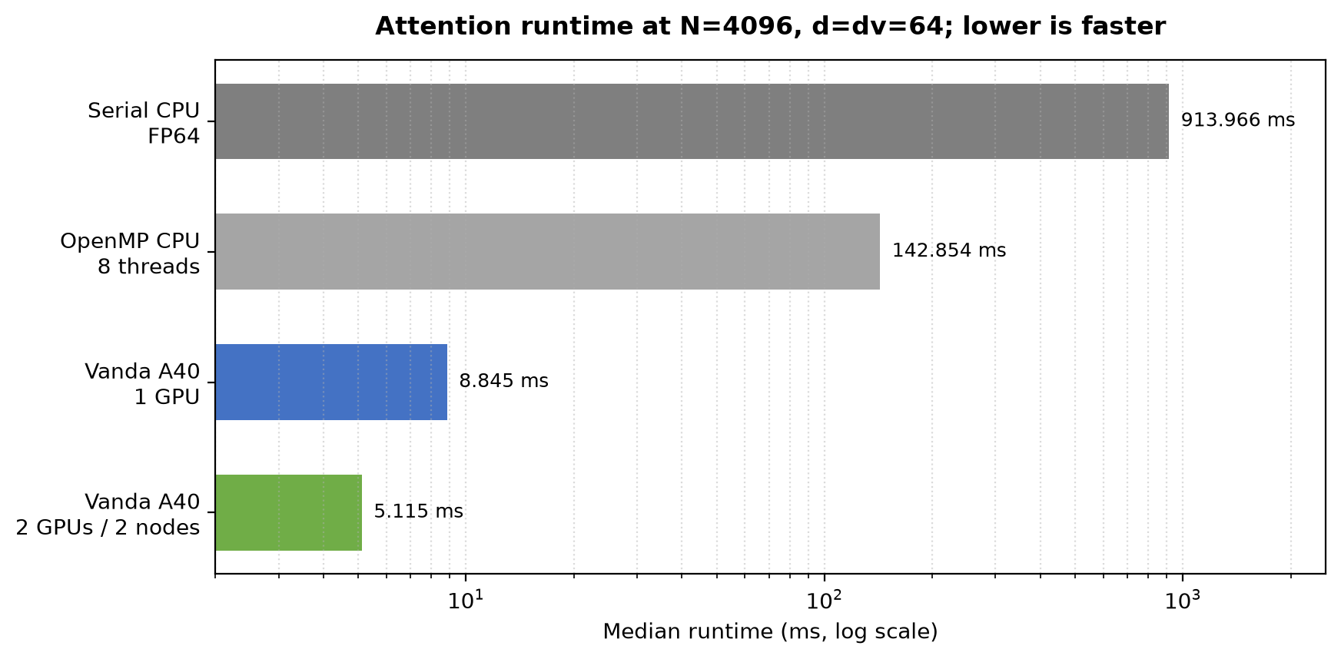
Figure 6. Runtime comparison at $N=4096$, $d=d_{v}=64$. Runtime is shown on a logarithmic horizontal axis.

4.2 Scaling with Sequence Length
For fixed feature dimensions, dense attention requires approximately quadratic arithmetic work as $N$ increases. Table 7 reports the runtime ratio for each doubling of sequence length.
Table 7. Runtime growth when sequence length doubles, with $d=d_{v}=64$.
$$N$$ | Serial CPU FP64 | Vanda A40, one-GPU FP32 | Runtime ratio vs previous row, CPU / GPU
512 | 17.515 ms | 0.248 ms | —
1024 | 70.418 ms | 0.648 ms | 4.02× / 2.61×
2048 | 263.479 ms | 2.345 ms | 3.74× / 3.62×
4096 | 913.966 ms | 8.845 ms | 3.47× / 3.77×
The empirical results generally align with the expected quadratic trend: scaling N from 512 to 4096 increases serial CPU and single-GPU runtimes by 3.47–4.02× and 2.61–3.77×, respectively. For extended sweeps up to N=65536, the scaling factors for Vanda A40 (both FP32 and FP64) consistently hover around 4.00×.
Furthermore, scaling the OpenMP thread count from one to eight at N=4096 reduces the CPU runtime from 914.491 ms to 142.854 ms. This reduction demonstrates that the CPU implementation scales effectively with multi-threaded parallel execution within the evaluated range.

4.3 Tile-Size Analysis
The two-node experiment tested different query and key/value tile sizes. Table 8 reports the measured runtimes.
Table 8. Two-node MPI+CUDA runtimes for different tile sizes.
$$N$$ | Query tile size $b_{q}$ | Key/value tile size $b_{k}$ | Median runtime
2048 | 64 | 128 | 4.011 ms
2048 | 64 | 256 | 2.493 ms
2048 | 128 | 128 | 2.288 ms
2048 | 128 | 256 | 1.469 ms
4096 | 64 | 128 | 15.308 ms
4096 | 64 | 256 | 9.361 ms
4096 | 128 | 128 | 8.169 ms
4096 | 128 | 256 | 5.124 ms
For $N=4096$, the number of query/key-value tile pairs is $\text{ceil}\left(N/b_{q}\right)×\text{ceil}\left(N/b_{k}\right)$, which corresponds to 2048 pairs under the $64×128$ configuration and 512 pairs under the $128×256$ configuration. The measurement results show that $b_{q}=128$ and $b_{k}=256$ achieved the lowest runtime across both sequence lengths (for instance, when $N=4096$, the two-node median runtime dropped significantly from 15.308 ms to 5.124 ms). We believe that this is mainly because larger tiles reduce the number of loop iterations and allow more work to be performed on each loaded block.

4.4 Parallel Scaling and Communication
Table 9 reports the weak-scaling pairs. Increasing $N$ by approximately $\sqrt{2}$ when moving from one GPU to two GPUs is intended to keep the arithmetic work per GPU approximately constant.
Table 9. weak-scaling results for smaller sequence lengths.
One-GPU$N$ | One-GPU runtime | Two-node $N$ | Two-node runtime
512 | 0.248 ms | 724 | 0.708 ms
1024 | 0.648 ms | 1448 | 1.263 ms
2048 | 2.345 ms | 2896 | 3.181 ms
4096 | 8.845 ms | 5793 | 11.225 ms
The two-node runtime was higher in all four cases. The ratio between the two-node and one-GPU runtimes decreased from 2.85× for $N=512/724$ to 1.27× for $N=4096/5793$.
Table 10 compares the runtimes of one and two Vanda A40 GPUs as the sequence length increases.
Table 10. Vanda A40 single-GPU and two-GPU strong scaling (FP32,$d=d_{v}=64$).
N | 1 A40 (ms) | 2 A40 (ms) | Speedup | Efficiency
1024 | 0.574512 | 0.592512 | 0.970× | 48.48%
2048 | 2.142314 | 1.798682 | 1.191× | 59.55%
4096 | 8.468848 | 5.212960 | 1.625× | 81.23%
8192 | 33.378822 | 18.490724 | 1.805× | 90.26%
16384 | 137.157641 | 72.481874 | 1.892× | 94.62%
32768 | 547.722869 | 279.146820 | 1.962× | 98.11%
65536 | 2197.395434 | 1103.821834 | 1.991× | 99.54%
Speedup is $T_{1}/T_{2}$, and two-GPU efficiency is speedup divided by 2. The two-GPU run was slightly slower at $N=1024$, but faster at every larger sequence length. Its speedup reached 1.991× at $N=65536$.
Figure 7 shows the runtime measurements from Table 10.
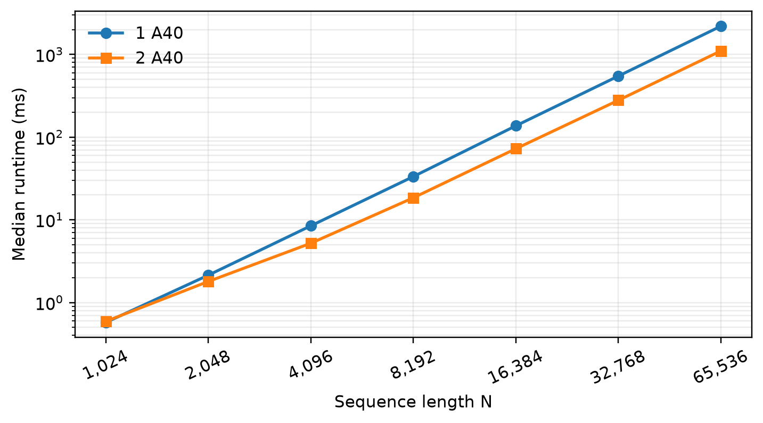
Figure 7. Median runtime on one and two Vanda A40 GPUs for the paired strong-scaling sweep.
Table 11 reports the Vanda CPU runtime as the OpenMP thread count increases.
Table 11. Vanda OpenMP scaling at N=4096 (FP64).
Threads | Median (ms) | Speedup | Efficiency
1 | 793.915 | 1.000× | 100.00%
2 | 413.925 | 1.918× | 95.90%
4 | 208.306 | 3.811× | 95.28%
8 | 143.319 | 5.540× | 69.24%
16 | 72.115 | 11.009× | 68.81%
32 | 37.854 | 20.973× | 65.54%
48 | 26.098 | 30.420× | 63.38%
64 | 18.817 | 42.192× | 65.93%
72 | 17.353 | 45.751× | 63.54%
Each runtime is the median of five runs from one Vanda job. Speedup is relative to the one-thread runtime, and efficiency is speedup divided by thread count. At 72 threads, runtime fell from 793.915 ms to 17.353 ms, giving a speedup of 45.751× and an efficiency of 63.54%.
Figure 8 plots the speedup and efficiency measured in the OpenMP runs.
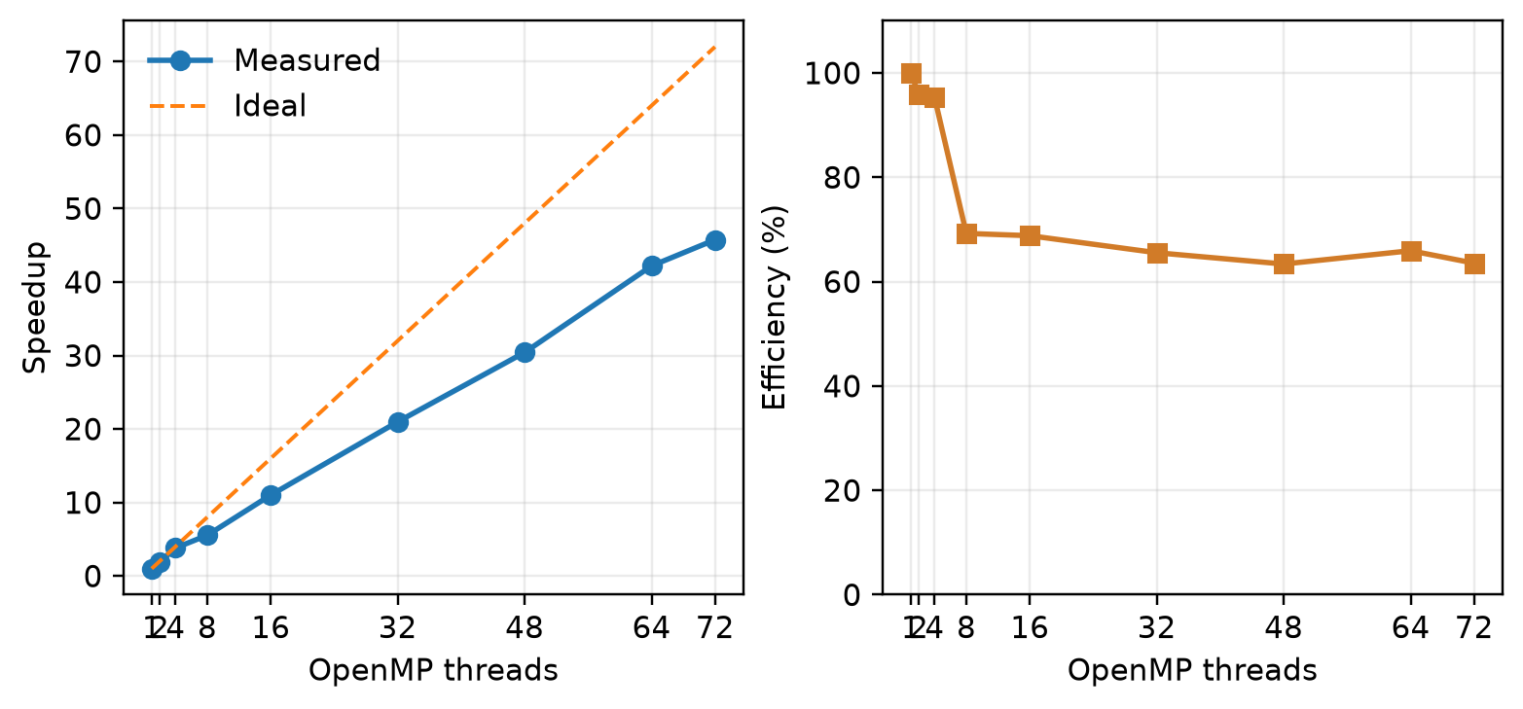
Figure 8. OpenMP speedup and parallel efficiency at N=4096 on Vanda.
Table 12 separates A40 timing into host-to-device transfer, attention computation, total timed runtime, and device-to-host transfer.
Table 12. Vanda A40 host-to-device and device-to-host transfer measurements.
N | H2D (ms) | Compute (ms) | Timed total (ms) | D2H (ms)
4096 | 0.101770 | 8.686738 | 8.810445 | 0.316062
8192 | 0.188904 | 35.076633 | 35.308300 | 0.593509
16384 | 0.354950 | 138.899148 | 139.287096 | 1.582626
Timed total includes H2D upload and attention computation and excludes D2H, which was measured separately. Attention computation accounted for more than 98% of the timed total at all three sequence lengths.
Table 13 reports a separate repeated run of the weak-scaling cases in Table 9. This run also measured the MPI phase.
Table 13. Repeated Vanda weak-scaling results and measured MPI phase.
N, 1 GPU | N, 2 GPUs | 1-GPU total | 2-GPU total | MPI phase (ms) | MPI increase
512 | 724 | 0.168798 | 0.413735 | 0.162974 | 66.5%
1024 | 1448 | 0.574512 | 0.911983 | 0.214074 | 63.0%
2048 | 2896 | 2.142314 | 2.861742 | 0.396395 | 56.1%
4096 | 5793 | 8.468848 | 10.124617 | 0.877383 | 52.0%
In all four repeated cases, the two-GPU runtime was higher than the one-GPU runtime. The MPI phase accounted for 52.0%–66.5% of the runtime increase.

5 Conclusion
This project successfully validates both the single-GPU CUDA attention kernel and the cross-node two-node MPI ring pipeline on local RTX 4090 and cluster Vanda A40 GPUs.
Distributed Communication & Deployment: We identified and resolved the initial multi-node launch failure (Job 1475534), where Open MPI incorrectly co-located both ranks on a single node. Adopting explicit --map-by ppr:1:node mapping ensured true multi-node distribution.
Correctness & Precision: Under $N=257,d=31,dv=19$ validation configurations against an FP64 CPU reference, both full and causal Ring Attention kernels achieved maximum absolute errors on the order of ${10}^{-8}$ and relative $L_{2}$ errors on the order of ${10}^{-7}$, successfully passing all verification checks.
Performance Scaling: For $N=4096,d=dv=64$, OpenMP CPU scaling reduced runtime from 913.97 ms (serial) to 142.85 ms (8 threads). Transitioning to a single Vanda A40 GPU achieved 8.85 ms (~103× speedup over serial CPU), and two-node MPI+CUDA Ring Attention further reduced runtime to 5.12 ms (a 1.73× speedup over single-GPU).
Tile Sizing & Causal Masking: Increasing tile dimensions (e.g., $bq=128,bk=256$) significantly boosted compute throughput, lowering two-node runtime at $N=4096$ from 15.31 ms to 5.12 ms. Under identical tile settings, causal and full attention execution times remained close (5.69 ms vs. 5.23 ms at $N=4096$).
Weak Scaling Behavior: Scaling sequence length $N$ by $\sqrt{2}$ alongside GPU rank count maintains approximate constant workload per device, exhibiting favorable weak scaling (e.g., 8.85 ms for $N=4096$ on 1 GPU vs. 11.23 ms for $N=5793$ on 2 nodes). This confirms that online softmax streaming and ring communication effectively reduce memory overhead while maintaining computational efficiency for scaled sequence lengths.

APPENDIX

Appendix 1: Ring Attention CUDA Kernel Validation on RTX 4090
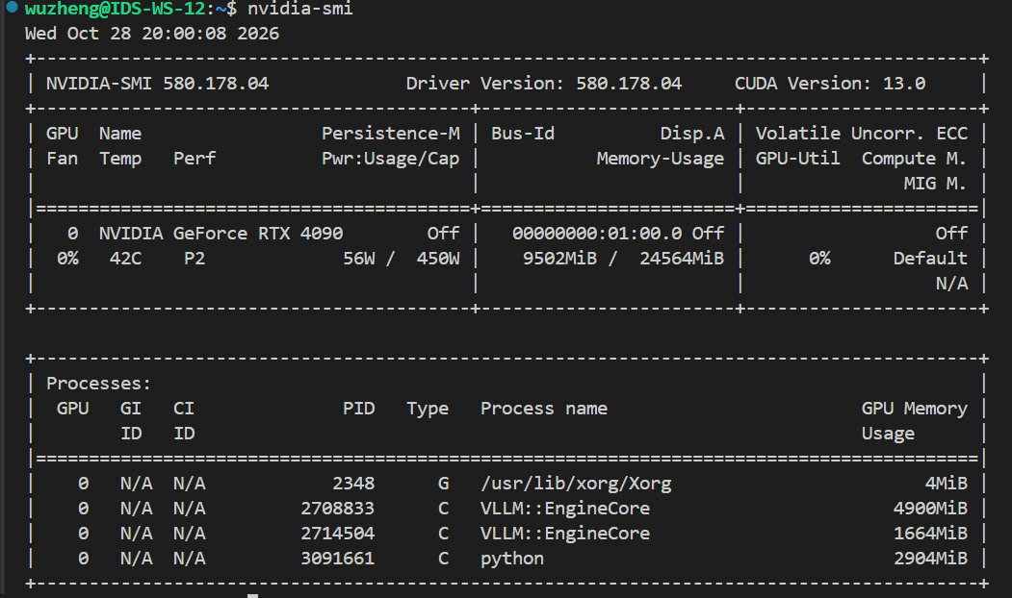
Figure 1. Local NVIDIA GeForce RTX 4090 GPU identification.
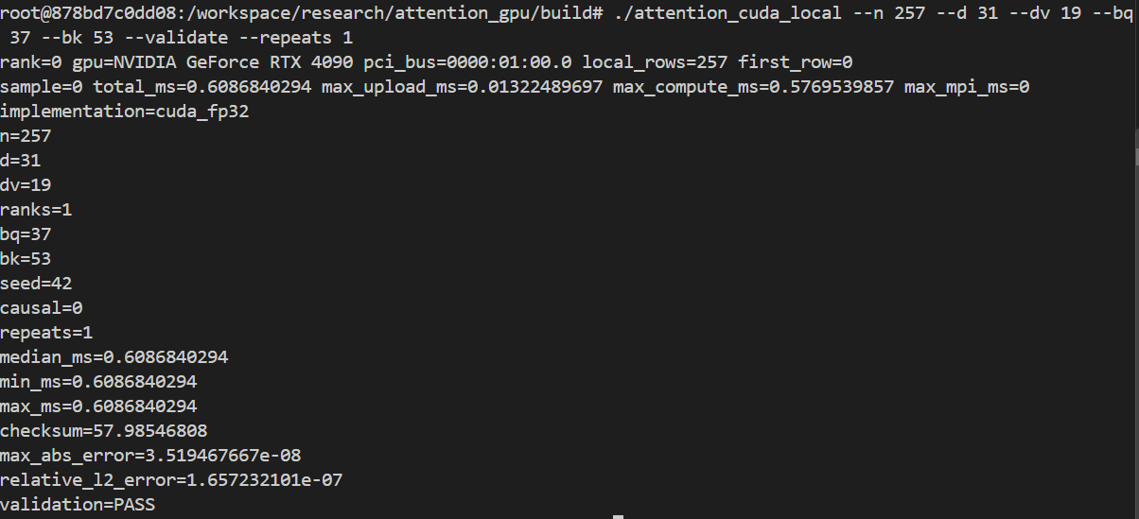
Figure 2. Local RTX 4090 full-attention validation at$N=257$.
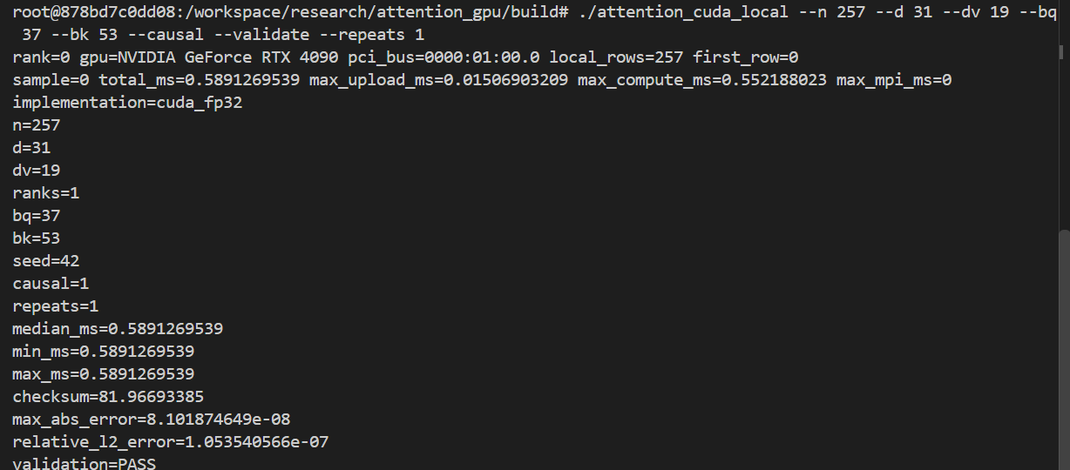
Figure 3. Local RTX 4090 causal-attention validation at $N=257$.
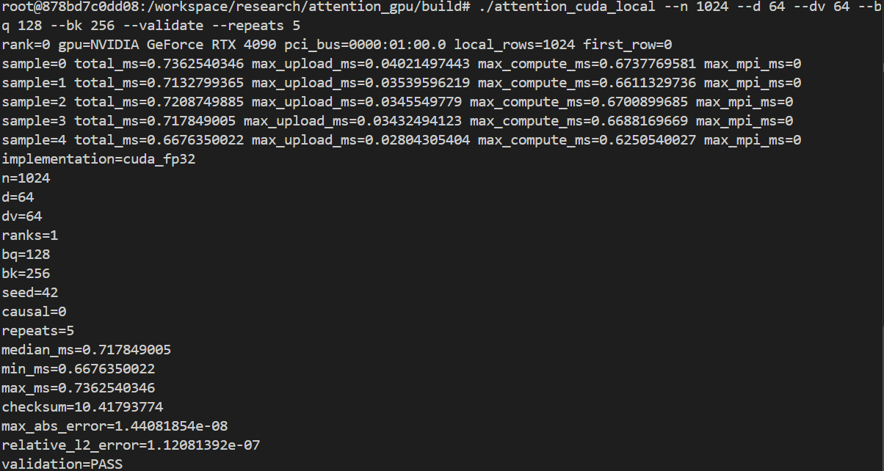
Figure 4. Local RTX 4090 full-attention benchmark at $N=1024$.
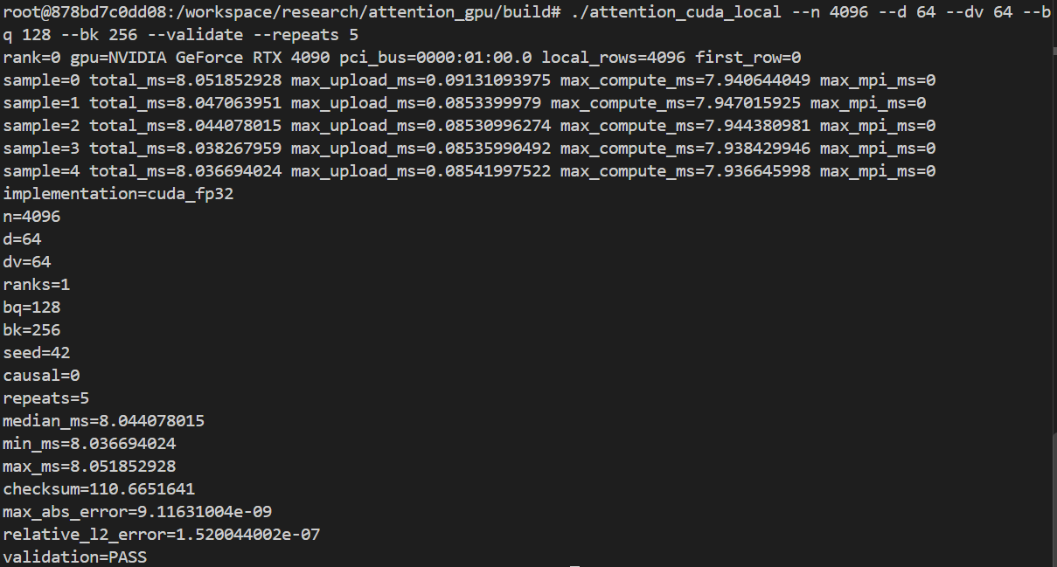
Figure 5. Local RTX 4090 full-attention benchmark at $N=4096$.

Appendix 2 Execution Log
1. # JOB 1470561 | scripts/vanda_serial_free.pbs
2. #!/bin/bash
3. #PBS -q auto_free
4. #PBS -N attention_serial_cpu
5. #PBS -j oe
6. #PBS -l select=1:ncpus=1:mpiprocs=1:mem=4gb
7. #PBS -l walltime=00:30:00
8. set -euo pipefail
9. cd "$PBS_O_WORKDIR"
10. mkdir -p bin results
11. module load gcc/13.1.0
12. g++ -O3 -std=c++11 src/attention_serial.cpp -o bin/attention_serial
13. bin/attention_serial --n 257 --d 31 --dv 19 --repeats 5 --check > results/serial_cpu_257.txt
14. for n in 512 1024 2048 4096; do
15. bin/attention_serial --n "$n" --d 64 --dv 64 --repeats 5 > "results/serial_cpu_${n}.txt"
16. done
17. bin/attention_serial --n 2048 --d 64 --dv 64 --causal --repeats 5 > results/serial_cpu_2048_causal.txt
18. echo "serial_cpu_benchmarks=PASS"
19. # JOB 1470659 | scripts/vanda_openmp_free.pbs
20. #!/bin/bash
21. #PBS -q auto_free
22. #PBS -N attention_openmp_opt
23. #PBS -j oe
24. #PBS -l select=1:ncpus=8:mpiprocs=1:ompthreads=8:mem=16gb
25. #PBS -l walltime=00:30:00
26. set -euo pipefail
27. cd "$PBS_O_WORKDIR"
28. mkdir -p bin results/openmp_opt
29. module load gcc/13.1.0
30. g++ -O3 -std=c++17 -fopenmp src/attention_openmp.cpp -o bin/attention_openmp_opt
31. OMP_PLACES=cores OMP_PROC_BIND=close bin/attention_openmp_opt --n 257 --d 31 --dv 19 --threads 8 --repeats 3 --check > results/openmp_opt/openmp_257_t8.txt
32. for n in 1024 2048 4096 8192; do
33. for t in 1 2 4 8; do
34. OMP_PLACES=cores OMP_PROC_BIND=close bin/attention_openmp_opt --n "$n" --d 64 --dv 64 --threads "$t" --repeats 5 > "results/openmp_opt/openmp_${n}_t${t}.txt"
35. done
36. done
37. echo "openmp_cpu_benchmarks=PASS"
38. # LOCAL NVIDIA RTX 4090 | one-GPU CUDA validation
39. /tmp/attention_cuda_env/bin/nvcc -O2 -std=c++17 -arch=sm_89 \
40. -I/tmp/attention_cuda_env/include \
41. -I/opt/conda/lib/python3.11/site-packages/nvidia/cublas/include \
42. /tmp/attention_local/src/attention_cuda.cu \
43. -L/tmp/attention_cuda_env/lib -lcublas \
44. -o /tmp/attention_local/bin/attention_cuda
45. LD_LIBRARY_PATH=/tmp/attention_cuda_env/lib:/opt/conda/lib/python3.11/site-packages/nvidia/cublas/lib:/opt/conda/lib/python3.11/site-packages/nvidia/cuda_runtime/lib:${LD_LIBRARY_PATH:-} \
46. /tmp/attention_local/bin/attention_cuda \
47. --n 257 --d 31 --dv 19 --bq 37 --bk 53 --validate --repeats 1
48. # JOB 1475534 | initial placement check | no attention kernel was launched
49. MPI=(mpirun --prefix "$MPI_HOME" --hostfile "$HOSTFILE" -x PATH -x LD_LIBRARY_PATH -np 2)
50. HOST_OUTPUT="$("${MPI[@]}" hostname)"
51. mapfile -t LAUNCHED_HOSTS < <(printf '%s\n' "$HOST_OUTPUT" | sort -u)
52. printf 'MPI rank hosts: %s\n' "${LAUNCHED_HOSTS[*]}"
53. if [[ "${#LAUNCHED_HOSTS[@]}" -ne 2 ]]; then
54. echo "ERROR: expected two MPI ranks on two distinct nodes"
55. exit 22
56. fi

57. # JOB 1476015 | scripts/vanda_attention_multinode_smoke_free.pbs
58. #!/bin/bash
59. #PBS -q auto_free
60. #PBS -N attention_2node_smoke
61. #PBS -j oe
62. #PBS -l select=2:ncpus=4:mpiprocs=1:ngpus=1:node_pool=gpu_free:mem=16GB
63. #PBS -l place=scatter
64. #PBS -l walltime=00:10:00
65. set -euo pipefail
66. cd "$PBS_O_WORKDIR"
67. module load gcc/13.1.0
68. module load cuda12.4/toolkit/12.4.1
69. module load openmpi/gcc/64/4.1.8
70. MPI_BIN="$(readlink -f "$(command -v mpirun)")"
71. MPI_HOME="${MPI_HOME:-$(dirname "$(dirname "$MPI_BIN")")}"
72. export MPI_HOME PATH="$MPI_HOME/bin:$PATH"
73. export LD_LIBRARY_PATH="$MPI_HOME/lib:$MPI_HOME/lib64:${LD_LIBRARY_PATH:-}"
74. export OMPI_MCA_plm_rsh_agent=ssh
75. OUT=results/multinode_smoke_free
76. mkdir -p "$OUT" bin
77. HOSTFILE="$OUT/mpi_hosts"
78. sort -u "$PBS_NODEFILE" > "$HOSTFILE"
79. [[ "$(wc -l < "$HOSTFILE")" -eq 2 ]]
80. nvcc -O3 -std=c++17 -arch=sm_86 -ccbin mpicxx -DATTENTION_MPI=1 -DOMPI_SKIP_MPICXX=1 src/attention_cuda.cu -lcublas -o bin/attention_mpi_cuda
81. MPI=(mpirun --prefix "$MPI_HOME" --hostfile "$HOSTFILE" --map-by ppr:1:node --rank-by node -x PATH -x LD_LIBRARY_PATH -np 2)
82. HOST_OUTPUT="$("${MPI[@]}" hostname)"
83. mapfile -t RANK_HOSTS < <(printf '%s\n' "$HOST_OUTPUT" | sort -u)
84. [[ "${#RANK_HOSTS[@]}" -eq 2 ]]
85. "${MPI[@]}" bin/attention_mpi_cuda --n 257 --d 31 --dv 19 --bq 37 --bk 53 --validate --repeats 1
86. echo "MULTINODE_SMOKE=PASS"
87. # JOB 1476284 | scripts/vanda_attention_multinode_all_free.pbs
88. #!/bin/bash
89. #PBS -q auto_free
90. #PBS -N attention_2node_all
91. #PBS -j oe
92. #PBS -l select=2:ncpus=4:mpiprocs=1:ngpus=1:node_pool=gpu_free:mem=16GB
93. #PBS -l place=scatter
94. #PBS -l walltime=01:00:00
95. set -euo pipefail
96. cd "$PBS_O_WORKDIR"
97. mkdir -p bin results/multinode_all
98. module load gcc/13.1.0
99. module load cuda12.4/toolkit/12.4.1
100. module load openmpi/gcc/64/4.1.8
101. MPI_BIN="$(readlink -f "$(command -v mpirun)")"
102. MPI_HOME="${MPI_HOME:-$(dirname "$(dirname "$MPI_BIN")")}"
103. export MPI_HOME PATH="$MPI_HOME/bin:$PATH"
104. export LD_LIBRARY_PATH="$MPI_HOME/lib:$MPI_HOME/lib64:${LD_LIBRARY_PATH:-}"
105. export OMPI_MCA_plm_rsh_agent=ssh
106. OUT=results/multinode_all
107. HOSTFILE="$OUT/mpi_hosts"
108. sort -u "$PBS_NODEFILE" > "$HOSTFILE"
109. [[ "$(wc -l < "$HOSTFILE")" -eq 2 ]]
110. g++ -O3 -std=c++11 src/attention_serial.cpp -o bin/attention_serial
111. nvcc -O3 -std=c++17 -arch=sm_86 src/attention_cuda.cu -lcublas -o bin/attention_cuda
112. nvcc -O3 -std=c++17 -arch=sm_86 -ccbin mpicxx -DATTENTION_MPI=1 -DOMPI_SKIP_MPICXX=1 src/attention_cuda.cu -lcublas -o bin/attention_mpi_cuda
113. MPI=(mpirun --prefix "$MPI_HOME" --hostfile "$HOSTFILE" --map-by ppr:1:node --rank-by node -x PATH -x LD_LIBRARY_PATH -np 2)
114. HOST_OUTPUT="$("${MPI[@]}" hostname)"
115. mapfile -t LAUNCHED_HOSTS < <(printf '%s\n' "$HOST_OUTPUT" | sort -u)
116. [[ "${#LAUNCHED_HOSTS[@]}" -eq 2 ]]
117. "${MPI[@]}" bin/attention_mpi_cuda --n 257 --d 31 --dv 19 --bq 37 --bk 53 --validate --repeats 3 --output "$OUT/ring_257.csv"
118. "${MPI[@]}" bin/attention_mpi_cuda --n 257 --d 31 --dv 19 --bq 37 --bk 53 --causal --validate --repeats 3 --output "$OUT/ring_causal_257.csv"
119. for n in 1024 2048 4096 8192; do
120. "${MPI[@]}" bin/attention_mpi_cuda --n "$n" --d 64 --dv 64 --bq 128 --bk 256 --repeats 5
121. done
122. for n in 2048 4096; do
123. for bq_bk in "64 128" "64 256" "128 128" "128 256"; do
124. read -r bq bk <<< "$bq_bk"
125. "${MPI[@]}" bin/attention_mpi_cuda --n "$n" --d 64 --dv 64 --bq "$bq" --bk "$bk" --repeats 3
126. done
127. done
128. for n in 4096 8192; do
129. for mask in full causal; do
130. args=()
131. if [[ "$mask" == causal ]]; then args+=(--causal); fi
132. "${MPI[@]}" bin/attention_mpi_cuda --n "$n" --d 64 --dv 64 --bq 128 --bk 256 --repeats 5 "${args[@]}"
133. done
134. done
135. for pair in "512 724" "1024 1448" "2048 2896" "4096 5793"; do
136. read -r n1 n2 <<< "$pair"
137. bin/attention_cuda --n "$n1" --d 64 --dv 64 --bq 128 --bk 256 --repeats 5
138. "${MPI[@]}" bin/attention_mpi_cuda --n "$n2" --d 64 --dv 64 --bq 128 --bk 256 --repeats 5
139. done
140. echo "MULTINODE_FULL_EXPERIMENTS=PASS"

141. # JOB 1476448 | scripts/vanda_attention_multinode_all_batch.pbs
142. #!/bin/bash
143. #PBS -P personal-dongwuzheng
144. #PBS -q auto
145. #PBS -N attention_2node_batch
146. #PBS -j oe
147. #PBS -l select=2:ncpus=4:mpiprocs=1:ngpus=1:mem=16GB
148. #PBS -l place=scatter
149. #PBS -l walltime=01:00:00
150. set -euo pipefail
151. cd "$PBS_O_WORKDIR"
152. mkdir -p bin results/multinode_all
153. module load gcc/13.1.0
154. module load cuda12.4/toolkit/12.4.1
155. module load openmpi/gcc/64/4.1.8
156. MPI_BIN="$(readlink -f "$(command -v mpirun)")"
157. MPI_HOME="${MPI_HOME:-$(dirname "$(dirname "$MPI_BIN")")}"
158. export MPI_HOME PATH="$MPI_HOME/bin:$PATH"
159. export LD_LIBRARY_PATH="$MPI_HOME/lib:$MPI_HOME/lib64:${LD_LIBRARY_PATH:-}"
160. export OMPI_MCA_plm_rsh_agent=ssh
161. OUT=results/multinode_all
162. HOSTFILE="$OUT/mpi_hosts"
163. sort -u "$PBS_NODEFILE" > "$HOSTFILE"
164. [[ "$(wc -l < "$HOSTFILE")" -eq 2 ]]
165. g++ -O3 -std=c++11 src/attention_serial.cpp -o bin/attention_serial
166. nvcc -O3 -std=c++17 -arch=sm_86 src/attention_cuda.cu -lcublas -o bin/attention_cuda
167. nvcc -O3 -std=c++17 -arch=sm_86 -ccbin mpicxx -DATTENTION_MPI=1 -DOMPI_SKIP_MPICXX=1 src/attention_cuda.cu -lcublas -o bin/attention_mpi_cuda
168. MPI=(mpirun --prefix "$MPI_HOME" --hostfile "$HOSTFILE" --map-by ppr:1:node --rank-by node -x PATH -x LD_LIBRARY_PATH -np 2)
169. HOST_OUTPUT="$("${MPI[@]}" hostname)"
170. mapfile -t LAUNCHED_HOSTS < <(printf '%s\n' "$HOST_OUTPUT" | sort -u)
171. [[ "${#LAUNCHED_HOSTS[@]}" -eq 2 ]]
172. "${MPI[@]}" bin/attention_mpi_cuda --n 257 --d 31 --dv 19 --bq 37 --bk 53 --validate --repeats 3 --output "$OUT/ring_257.csv"
173. "${MPI[@]}" bin/attention_mpi_cuda --n 257 --d 31 --dv 19 --bq 37 --bk 53 --causal --validate --repeats 3 --output "$OUT/ring_causal_257.csv"
174. for n in 1024 2048 4096 8192; do
175. "${MPI[@]}" bin/attention_mpi_cuda --n "$n" --d 64 --dv 64 --bq 128 --bk 256 --repeats 5
176. done
177. for n in 2048 4096; do
178. for bq_bk in "64 128" "64 256" "128 128" "128 256"; do
179. read -r bq bk <<< "$bq_bk"
180. "${MPI[@]}" bin/attention_mpi_cuda --n "$n" --d 64 --dv 64 --bq "$bq" --bk "$bk" --repeats 3
181. done
182. done
183. for n in 4096 8192; do
184. for mask in full causal; do
185. args=()
186. if [[ "$mask" == causal ]]; then args+=(--causal); fi
187. "${MPI[@]}" bin/attention_mpi_cuda --n "$n" --d 64 --dv 64 --bq 128 --bk 256 --repeats 5 "${args[@]}"
188. done
189. done
190. for pair in "512 724" "1024 1448" "2048 2896" "4096 5793"; do
191. read -r n1 n2 <<< "$pair"
192. bin/attention_cuda --n "$n1" --d 64 --dv 64 --bq 128 --bk 256 --repeats 5
193. "${MPI[@]}" bin/attention_mpi_cuda --n "$n2" --d 64 --dv 64 --bq 128 --bk 256 --repeats 5
194. done
195. echo "MULTINODE_FULL_EXPERIMENTS=PASS"
196. # JOB 1475539 | scripts/vanda_attention_single_node_check_free.pbs
197. #!/bin/bash
198. #PBS -q auto_free
199. #PBS -N attention_1node_check
200. #PBS -j oe
201. #PBS -l select=1:ncpus=8:mpiprocs=2:ngpus=2:mem=16GB:node_pool=gpu_free
202. #PBS -l place=pack
203. #PBS -l walltime=00:10:00
204. set -euo pipefail
205. cd "$PBS_O_WORKDIR"
206. mkdir -p bin results/multinode_all
207. module load gcc/13.1.0
208. module load cuda12.4/toolkit/12.4.1
209. module load openmpi/gcc/64/4.1.8
210. MPI_BIN="$(readlink -f "$(command -v mpirun)")"
211. MPI_HOME="$(dirname "$(dirname "$MPI_BIN")")"
212. export PATH="$MPI_HOME/bin:$PATH"
213. export LD_LIBRARY_PATH="$MPI_HOME/lib:$MPI_HOME/lib64:${LD_LIBRARY_PATH:-}"
214. nvcc -O2 -std=c++17 -arch=sm_86 -ccbin mpicxx -DATTENTION_MPI=1 -DOMPI_SKIP_MPICXX=1 src/attention_cuda.cu -lcublas -o bin/attention_mpi_cuda_single_node_check
215. mpirun --prefix "$MPI_HOME" -np 2 --map-by ppr:2:node -x PATH -x LD_LIBRARY_PATH bin/attention_mpi_cuda_single_node_check --n 257 --d 31 --dv 19 --bq 37 --bk 53 --validate --repeats 1 --output "results/multinode_all/single_node_check_${PBS_JOBID}.csv"
216.

